# **Hospital Management System**

### **A detailed view of Hospital Management System (HMS)**



Submitted To

# Mohammad Ehsan Shahmi Chowdhury

**Senior Lecturer**

Department of CSE

Green University of Bangladesh

Submitted By

***Md. Parvej Hossain***

ID: 181002085

**Farjana Sahab**

ID: 181002046

Group number - 02

Section: 181_DC

Department of CSE

Green University of Bangladesh

**TABLE OF CONTENT**

|  |  |  |
| --- | --- | --- |
| **SNO** | **TITLE** | **PAGE** |
| 1 | Overview | 3 |
| 2 | Procedure | 3 |
| 3 | Used Components | 4 |
| 4 | Hospital Segments, Features and Services | 5 |
| 5 | Methodology | 6 |
| 6 | Results | 7 |
| 7 | Discussion after every figure | 7 |
| 8 | All output’s screenshots, etc | 8 |
| 9 | Conclusion | 8 |

1. **Overview:**
2. **Motivation -**This Project is very helpful in every hospital management system where patient will take easily their health care.
3. **Application –** If this system is implemented in all large and advanced hospitals patients, doctors will be able to receive treatment and hospital management will be able to manage them very easily.
4. **Procedure:**
5. **Theory-**

**ABSTRACT**

This report describes the network design of Hospital Management System. In this network topology the nodes (i.e., computers, switches, routers or other devices) are connected to a local area network (LAN) and network via links (twisted pair copper wire cable or optical fiber cable). We have used Cisco Packet Tracer for designing the network topology It’s a general design which can be implemented at any higher level to manage network system.

* **DHCP**

The Dynamic Host Configuration Protocol (DHCP) is a network management protocol used on UDP/IP networks whereby a DHCP server dynamically assigns an IP address and other network configuration parameters to each device on a network so they can communicate with other IP networks.

* **DNS**

The Domain Name System is a hierarchical and decentralized naming system for computers, services, or other resources connected to the Internet or a private network.

* **SUBNETTING**

A subnetwork or subnet is a logical subdivision of an IP network. The practice of dividing a network into two or more networks is called subnetting.

* **HTTPS**

Hypertext Transfer Protocol Secure is an extension of the Hypertext Transfer Protocol. It is used for secure communication over a computer network and is widely used on the Internet. Hypertext Transfer Protocol Secure is an extension of the Hypertext Transfer Protocol. It is used for secure communication over a computer network and is widely used on the Internet.

* **SSH**

Secure Shell is a cryptographic network protocol for operating network services securely over an unsecured network.

* **SMTP**

The Simple Mail Transfer Protocol is a communication protocol for electronic mail transmission.

* **FTP**

The File Transfer Protocol is a standard network protocol used for the transfer of computer files between a client and server on a computer network.

* **WIFI**

Wi-Fi is the name of a wireless networking technology that uses radio waves to provide wireless high-speed Internet and network connections.

**b. Used Components:**

**NETWORK REQUIREMENTS**

In Hospital Management Network topology, we have desktop Computer, laptops, smart phone. There is a data flow between the devices within the system. We have divided our network into segments like for Hospital wards, clinical area etc. We have also used SSH for security. Our network requirements include network devices like routers, switches, server.

**HOSPITAL SEGMENTS**

**1** General ward

**2** Private ward

**3** Clinical Area

**4** IT Department

**5** Entrance Reception

**6** Lobby and Parking

**FEATURES AND SERVICES**

**•** DHCP

**•** DNS

**•** Subnetting

**•** HTTPS

**•** SSH

**•** SMTP

**•** FTP

**•** WIFI

1. **Methodology-**

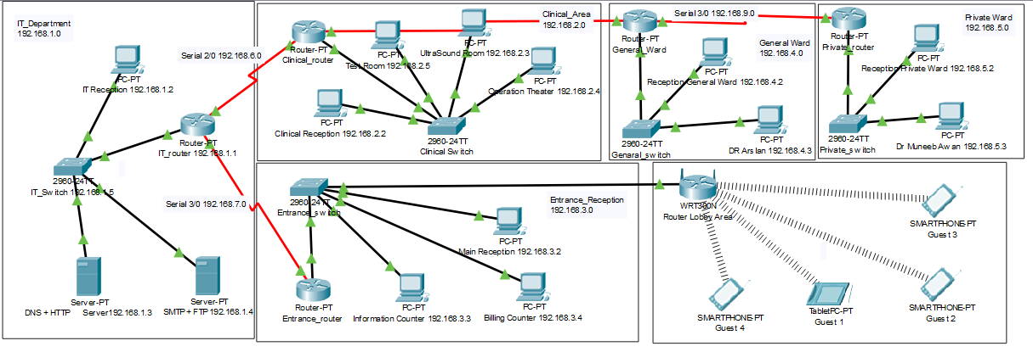

**3. Results**

**Screenshots:**

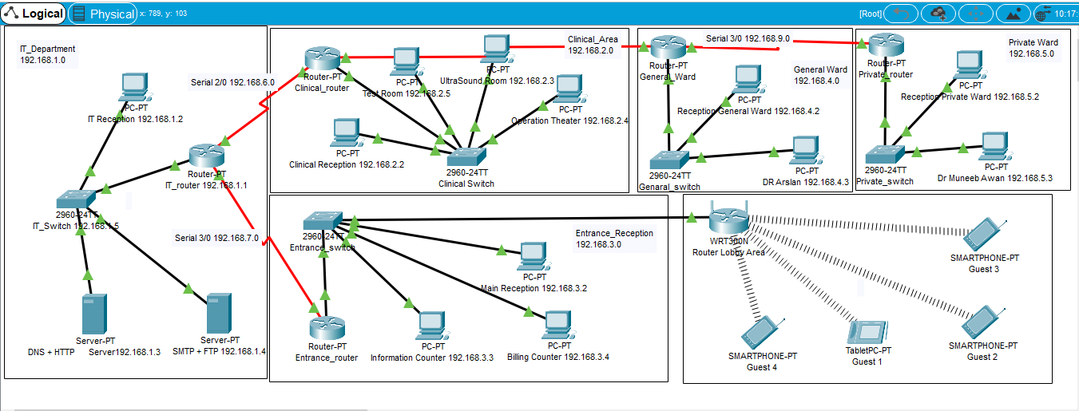

**Discussion after every Configuration-**

The diagram is properly commented. We have divided the diagram into 6 segments as named above. Hospital Segments representing different departments of hospital. Following are the running configuration of routers and switches related to different segments of hospital respectively:

|  |  |
| --- | --- |
| **General Ward Switch** | **General Ward Router** |
|  |  |

|  |  |
| --- | --- |
| **Private Ward Switch** | **Private Ward Router** |
|  |  |

|  |  |
| --- | --- |
| **Clinical Area Switch** | **Clinical Area Router** |
|  |  |

|  |  |
| --- | --- |
| **IT Department Switch** | **IT Department Router** |
|  |  |

|  |  |
| --- | --- |
| **Entrance Switch** | **Entrance Router** |
|  |  |

**All output’s screenshots:**

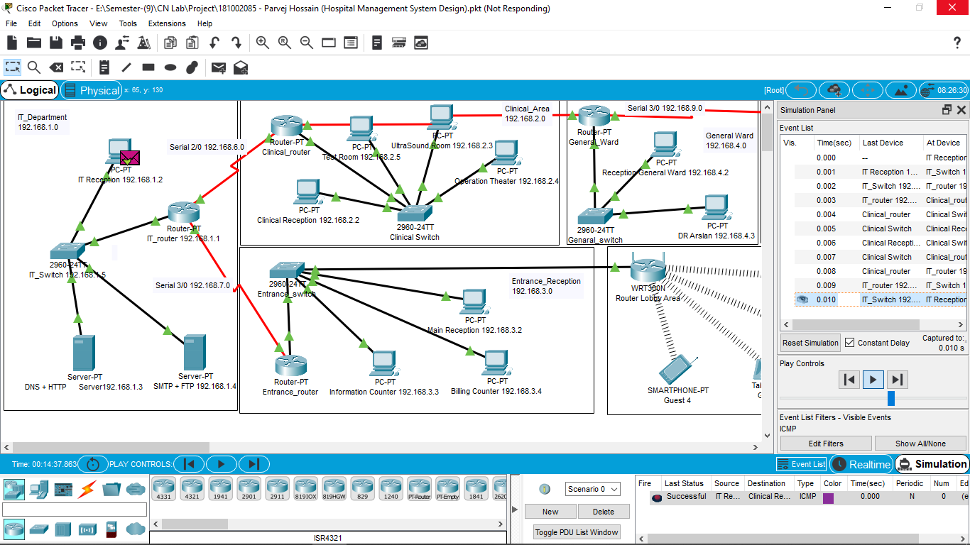

**4. CONCLUSION**

**Limitation:**

1. This topology can also be implemented on higher level of hospitals.
2. The price of equipment is high.

**Future Plan:**

In this project we can implemented on higher level of hospitals in our country.

**Official ending of Project:**

This report describes how we have designed network topology of hospital (Hospital Management System). With VLSM for Subnetting, segmented the diagram into 5 segments.